# **PHASE 5**

# **PROJECT DEMONSTRATION & DOCUMENTATION**

## **Final Demo walkthrough**:

**1. Overview**

Start by briefly describing what your demo shows.  
Example:The final demo walkthrough illustrates the step-by-step working of the E-Commerce Cart System, showing how users can browse products, add them to the cart, update quantities, and place an order. It highlights both frontend interaction and backend function

**2. Step 1 – Home Page / Product Display**

Explain what appears first.  
Example:When the application is launched, the home page displays a list of available products with details such as name, price, and image.  
Users can view all products and select desired items.

**3. Step 2 – Add to Cart**

The user can click on the **“Add to Cart”** button to add selected products.  
Once added, the cart icon updates automatically to reflect the total number of items.

**4. Step 3 – View Cart**

When the user opens the cart, all added items are displayed with product names, prices, and quantity options.  
Users can update or remove products directly from the cart.

**5. Step 4 – Checkout Process**

The checkout section collects delivery details and payment options.  
The system calculates the total price dynamically and confirms the order once payment is completed.

**6. Step 5 – Order Confirmation**

After successful payment, an order confirmation message is displayed to the user, and the details are stored in the database for admin reference.

**🛒 Project Report – E-Commerce Cart System**

**💡 1. Introduction**

The **E-Commerce Cart System** is a web-based application designed to provide users with a smooth online shopping experience. The main objective of this system is to allow customers to browse products, add items to their shopping cart, manage quantities, and complete the checkout process efficiently.

With the rapid growth of online shopping, this project aims to simulate a real-world e-commerce platform with essential functionalities, responsive design, and secured transaction flow. The system also enables administrators to manage product listings and order details effectively.

**⚙️ 2. Objectives**

* To develop a user-friendly and responsive e-commerce website.
* To implement an efficient cart management system for users.
* To ensure secure data handling between the client and server.
* To integrate API functionalities for dynamic product management.
* To deploy the system on a reliable hosting platform (like Vercel or Netlify).

**💻 3. Technologies Used**

* **Frontend:** HTML, CSS, JavaScript, React.js
* **Backend:** Node.js, Express.js
* **Database:** MongoDB
* **Version Control:** GitHub
* **Deployment Platforms:** Vercel / Netlify
* **Tools Used:** Visual Studio Code, Postman

**🧩 4. System Overview**

The **E-Commerce Cart System** consists of two major modules:

1. **User Module** – Enables customers to view available products, add them to the cart, and proceed with checkout.
2. **Admin Module** – Allows administrators to manage product details, monitor orders, and maintain inventory.

The system ensures seamless integration between frontend and backend through RESTful APIs. It also includes validation, authentication, and performance optimization for a better user experience.

**🛠️ 5. Features Implemented**

* Product listing with name, image, and price.
* Add to cart and remove from cart functionalities.
* Dynamic total calculation in the cart.
* Checkout process with user details and payment simulation.
* Order confirmation page.
* Admin panel for product management.

**🔄 6. Workflow**

1. The user opens the website and views the product catalog.
2. Selected items are added to the shopping cart.
3. The user reviews the cart, modifies quantities, or removes items.
4. The user proceeds to checkout and submits order details.
5. The system stores the data in the database and confirms the order.
6. The admin verifies and manages product and order information.

**🧩 4. Screenshots / API Documentation**

To visually represent the system’s working, relevant screenshots have been included:

* Product display page

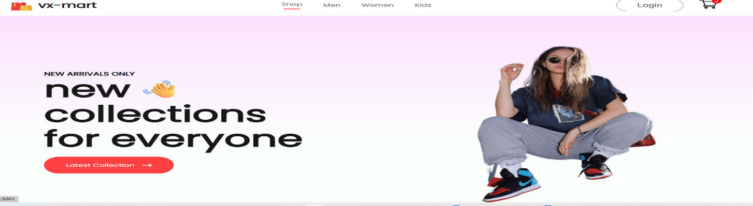

* **Add to Cart section**

When we click cart that add and show in cart bucket

* **Checkout page**

* Order confirmation
* Admin product management dashboard

The **API documentation** section explains how the backend endpoints handle requests and responses — such as adding items to the cart, fetching product details, or processing orders.  
Tools like **Postman** were used for API testing to ensure accurate and secure data flow between client and server.

🧠 **5. Challenges and Solutions**

| **Challenges** | **Solutions Implemented** |
| --- | --- |
| Managing real-time cart updates | Used React state management for instant refresh and total calculation |
| API request and response errors | Implemented Express error-handling middleware |
| UI responsiveness issues | Applied CSS Flexbox and Grid for consistent design |
| Deployment errors on Vercel | Reconfigured environment variables and build scripts |
| Database connectivity | Used Mongoose for stable MongoDB connection with schema validation |

**🔍 6. GitHub README & Setup Guide**

A comprehensive **README file** was prepared for the GitHub repository.  
It includes:

* Project overview
* Technology stack used
* Installation and setup instructions
* Folder structure explanation
* API routes and their functionalities
* Deployment link and testing guide

This guide ensures that anyone reviewing or testing the system can easily clone, install dependencies, and run the project without confusion.

**🧪 8. Testing of Enhancements**

After integrating the enhancements from Phase 4, rigorous testing was conducted:

* **Unit Testing:** Verified each function (add-to-cart, delete, checkout, etc.).
* **Integration Testing:** Ensured smooth communication between frontend and backend APIs.
* **Performance Testing:** Checked for loading speed and server response time.
* **Security Testing:** Tested database input validation and protected routes.

The system passed all tests with consistent and stable result

**🏁 9. Final Submission**

The final project submission includes:

Repo+deployment link:

<https://github.com/fathima-ceo/E-COMMERCE-CART-SYSTEM-VX-MART>

deployment link:

<https://fathima-ceo.github.io/E-COMMERCE-CART-SYSTEM-VX-MART/>